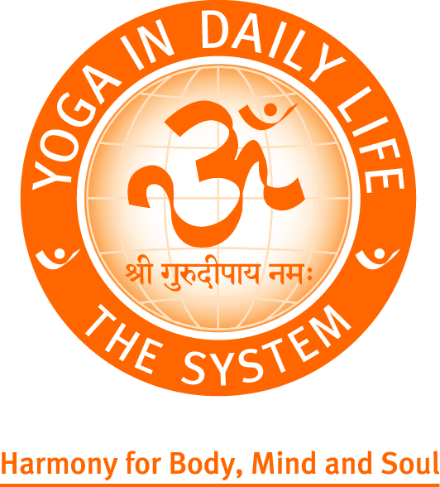
Weekend Seminar with
His Holiness Vishwaguru Paramhans
Swami Maheshwarananda
The Yogic Way of Healthy Life
Yoga in Daily Life Association – UK

London 12 – 14 October 2018

VENUES
Friday PM; Saturday AM & PM; Sunday AM: Malorees Infants School, Christchurch Ave, Kilburn NW6 7PB
Sunday PM: Sri Swami Madhavanandaji Ashram 133 Salusbury Rd, Queens Park NW6 6RN

 | Date | Programme | Entrance  Fee | Conc. Fee | No of places | Total £
Friday - Sunday | 12-14 October | Whole Weekend Seminar (not Conference)  (Public Lecture & Weekend Workshop includes 2 lunches + 3 dinners) | £110 | £85
Friday | 12 October | Public Lecture with Vishwaguruji – 7.30pm  Free for Standing Order members | £15 | £10
Saturday - Sunday | 13-14 October | Weekend Workshop  (includes Sat lunch & dinner, Sun dinner) | £100 | £80
Saturday | 13 October | Saturday Seminar programme  8am-12noon morning (10am Vishwaguruji, 2-5pm afternoon, 7pm evening with Vishwaguruji; lunch 12pm & dinner 5pm | £85 | £75
Saturday | 13 October | Evening Lecture with Vishwaguruji – 7 pm | £15 | £10
Sunday | 14 October | Sunday Morning Workshop – 8am  10am with Vishwaguruji (lunch incl.) | £35 | £30
Sunday | 14 October | Sunday Evening Satsang – 7pm  7pm with Vishwaguruji (dinner 5-6pm) | by donation | by donation
TOTALS

………………………………………………………………………………………………………………………………………………………………………….

LONDON UK | 12 – 14 October 2018 | WITH HIS HOLINESS VISHWAGURUJI

BOOKING FORM (Data Protection: your details will be used only for the purposes of administering this event.)

Name/s of participant/s:

Telephone/Mobile: | Email:

PAYMENT
Amount Paid: £ ______ . | ☐ bank transfer: 08-92-99 | 6507 9209 | ☐ debit/credit card | ☐ cash (in person only)

Proceeds from the YIDL Seminar go towards Yoga in Daily Life humanitarian projects, thank you.
PROGRAMMES BOOKED
☐ Full Weekend Seminar 12-14/10 | ☐ Weekend Workshop 13-14/10
☐ Friday Public Lecture 12/10 | ☐ Saturday full day 13/10
☐ Saturday Daytime Workshop 13/10 | ☐ Saturday Evening Lecture 13/10
☐ Sunday Morning Workshop 14/10 | ☐ Sunday Evening Satsang 14/10

Yoga in Daily Life Association - UK | Sri Swami Madhavanandaji Ashram | 133 Salusbury Rd, London NW6 6RN
Tel: 020 7328 7163 E-mail: london@yogaindailylife.org Website: www.yogaindailylife.org.uk
A registered charity caring for all. Charity Reg. No: 1103366 Ltd Company No: 4657601

